Multiple-choice section

|  |  |  |  |  |  |  |  |  |  |  |
| --- | --- | --- | --- | --- | --- | --- | --- | --- | --- | --- |
| Question | 1 | 2 | 3 | 4 | 5 | 6 | 7 | 8 | 9 | 10 |
| Answer | B | C | B | C | D | C | B | D | D | C |

Question 1 [3.1]

B

18 ÷ 9 = 2

= 2 lollies

= 4 × 2

= 8 lollies

Question 2 [3.1]

C

= -49 ÷ 7

= -7

Question 3 [3.1]

B

One square = , two triangles =

Total area shaded = =

Question 4 [3.2]

C

HCF of 56 and 84 is 28.

Question 5 [3.3]

D





 is closer.

Question 6 [3.4]

C

=

=

Question 7 [3.4]

B

Both and are very close to 1, so their sum will be close to 2.

Question 8 [3.5]

D

of $240

× 



Question 9 [3.6]

D



Question 10 [3.7]

C

 strawberries

 strawberries

 strawberries

Multiple-choice total marks: 10

Short answer section

Question 11 2 marks [3.1, 3.2]

(a) You *simplify* fractions by cancelling common factors in the numerator and denominator.

(b) *Improper* fractions have a value greater than or equal to 1.

Question 12 3 marks [3.3]

Answers will vary. The lowest common denominator (LCD) is the smallest number that is a multiple of the denominators of two or more fractions. For example, the LCD of and is 12, because 4 × 3 =12, and 6 × 2 = 12.

Question 13 2 marks [3.2]

(× ), (× )... Multiply numerator and denominator by the same whole number.

Question 14 5 marks [3.4]

|  |  |
| --- | --- |
| (a) Alex’s working | (b) Correct working  LCD = 24  = +   =   = |

(c) Alex found the Lowest Common Denominator (LCD) correctly. He multiplied each of the denominators to obtain the LCD, but forgot to multiply the numerators as well.

Question 15 1 mark [3.1]

or

Question 16 3 marks [3.2]

|  |  |  |
| --- | --- | --- |
| (a) | (b) | (c) |

Question 17 6 marks [3.3]

|  |  |  |
| --- | --- | --- |
| (a)  but so is greater | (b)  > but so is greater | (c)  is closer to 1 than |

Question 18 9 marks [3.4]

|  |  |  |
| --- | --- | --- |
| (a) LCD = 60 =  =  = 1 = 1 | (b) LCD = 12 = 1 + 3 +  = 4 +  = 5 = | (c) LCD = 5 =  =  = |

Question 19 6 marks [3.5]

|  |  |  |
| --- | --- | --- |
| (a) of $55 | (b)  =  = | (c)  = |

Question 20 9 marks [3.6]

|  |  |  |
| --- | --- | --- |
| (a) | (b) | (c) |

Question 21 7 marks [3.7]

|  |  |
| --- | --- |
| (a) ÷ 2 × | (b) |

Short answer total: 52

Extended answer section

Question 22 9 marks [3.1, 3.2, 3.3]

(a)   
 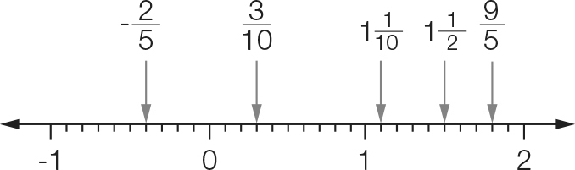

(b) , 

(c) 

(d)  , ,

(e) , , so there are 7 whole numbers between the two fractions: 2, 3, 4, 5, 6, 7, 8

Question 23 6 marks [3.4, 3.5]

(a) (i) B

(ii) Both fractions in the sum are greater than , and so the answer will be greater than 1. The other fraction sums have one or both fractions less than . (C has 1 fraction greater and one less than , but the fraction greater than , is less than both of the fractions in B).

(b) (i) D

(ii) Both of the numbers being multiplied are greater than 1. In two of the other multiplications (A and B) multiplying a fraction less than 1 by another fraction less than 1 gives a fraction smaller than both being multiplied. In C, a mixed number greater than 1 () is multiplied by a fraction less than 1, which will result in the mixed number being reduced in size. In D, the same mixed number is multiplied by an improper fraction, which will result in a larger number.

Extended answer total: 15

TOTAL test marks: 77